**Assessment Cover Page**

|  |  |
| --- | --- |
| *Student Full Name* | Felipe Luiz Bauer Steudel |
| *Student Number* | 2024153 |
| *Module Title* | Strategic Thinking |
| *Assessment Title* | Capstone Project Proposal |
| *Assessment Due Date* | March 29, 2024 |
| *Date of Submission* | March 29, 2024 |

**Declaration**

By submitting this assessment, I confirm that I have read the CCT policy on academic misconduct and understand the implications of submitting work that is not my own or does not appropriately reference material taken from a third party or other source.

I declare it to be my own work and that all material from third parties has been appropriately referenced.

I further confirm that this work has not previously been submitted for assessment by myself or someone else in CCT College Dublin or any other higher education institution.

# Title

Enhancing Maintenance Efficiency in Photovoltaic Solar Power Plants

# Introduction

Photovoltaic solar energy has been expanding significantly around the world, due to its generation being considered renewable and sustainable. Often, this source is seen as a way to diversify the energy matrix of countries, besides generating low environmental and social impacts. Despite this, solar energy still represents a very small portion of the global energy matrix, but this index is expected to increase in the coming years due to the high investment in so-called green energies and concern about climate change due to global warming.

Basically, a solar generation system consists of interconnected solar panels connected to an inverter, which in turn is connected to a main power panel. The solar panels are responsible for converting sunlight into Direct Current (DC) energy. The inverter converts the current to Alternating Current (AC) and matches its frequency with the utility grid frequency, transforming the energy into a usable form for storage in batteries or direct supply to the grid. The energy going into the grid passes through a bidirectional meter that measures the amount in kWh of supplied energy.

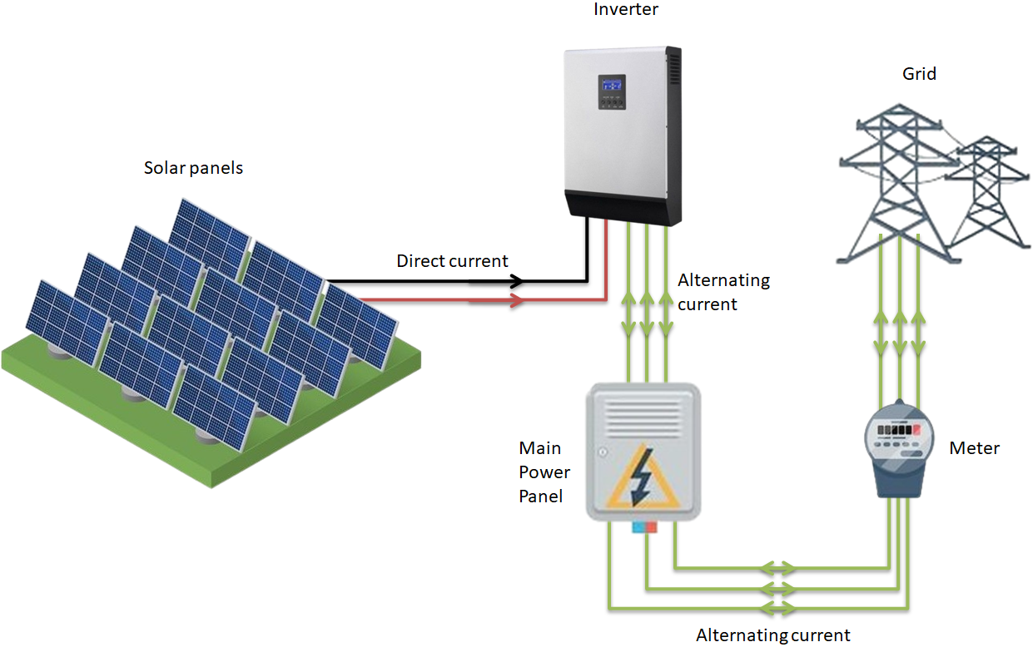

Solar energy is not always available; after all, we have nights and cloudy, rainy days. This requires efficient ways to transport and store energy, as well as requiring higher efficiency from photovoltaic cells. Nevertheless, the generation system presents its advantages: It generates less environmental impact since it is an energy generator that does not produce greenhouse gases; It has an infinite source of energy since it uses the sun to produce it; and has low operation and maintenance costs compared to the costs of other forms of energy generation.

Although Solar Plants are considered to have low maintenance costs, there is still a need for improvement in the operation and maintenance performance since a failure or defect can significantly reduce generation or even render the plant unable to generate energy.

A good way to ensure the efficiency of the solar system as a whole would be to understand how photovoltaic solar panels behave in different external temperatures and the levels of solar irradiation that fall on the panels, as well as providing swift maintenance to detect generation failures or decreases in energy efficiency in the components that make up a photovoltaic solar power plant.

# Objectives

**Monitoring and Predictive Maintenance**: The objective is to identify anomalies that may indicate the need for maintenance or cleaning of solar panels, using temperature and irradiation sensor data, ensuring that these panels operate in better conditions, increasing their performance and energy yield sustainably.

**Enhancement of Efficiency**: Through equipment performance data, it will be possible to identify equipment with inferior performance. The goal is to enhance the overall efficiency of the plant, reduce equipment downtime, and extend the lifespan of solar panels and inverters that make up the photovoltaic generation system.

**Effective Energy Generation Management**: The objective is to develop models that can accurately predict energy production by analyzing energy generation and solar irradiation metrics. This capability can reduce losses, enabling effective energy generation management and ensuring better electricity supply.

# Problem Definition

The lack of effective monitoring is one of the causes that make photovoltaic solar plants less efficient, leading to many unnecessary maintenance tasks, decreased equipment lifespan, and thus increasing the operation cost of the plant, as well as energy generation losses due to equipment downtime that required maintenance.

The increase in maintenance costs and the loss of energy generation directly impact the monetary gains that the plant is capable of generating, whether in the form of energy savings, where energy generation must exceed consumption, or when the generated energy is sold to the end customer, where reduced generation indicates a lower supply of electrical energy.

# Scope

The work will be organized into 4 milestones, each aiming to deliver a set of information.Milestones 1, 2, and 3 are deliveries related to 3 different types of information that can be collected from the Dataset, namely: Power, Production (Energy Generation), and Temperature. Milestone 4 will perform the correlation analysis among the three sets of information.

**Milestone 1 – Solar Plant Power Analysis**

* AC and DC Power per Equipment
* AC and DC Power Throughout the Day
* Daily Average of AC and DC Power
* Change in AC and DC Power Throughout the Day
* Conversion Rate from DC Power to AC Power

**Milestone 2 – Solar Plant Production Analysis**

* Daily and Total Production
* Daily Production per Equipment
* Hourly Daily Production
* Daily Energy Production
* Weekly Production
* Daily Yield

**Milestone 3 – Analysis of Temperature on the Solar Plant**

* Temperature Over Time
* Hourly Average Ambient Temperature
* Daily Average Temperatures and Irradiation
* Ambient Temperature vs. Irradiation
* Photovoltaic Panels Temperature vs. Ambient Temperature
* Average Irradiation per Hour of the Day of the Week
* Correlation Between Ambient Temperature and Irradiation

**Milestone 4 – Relationships between Power, Production, and Temperatures**

* Relationship between DC Power and Yield
* Relationship between Power and Irradiation Over Time
* Relationship between Irradiation and Production
* Relationship between Irradiation and AC Power
* Panels Temperature and Production Over Time

With this information, there is an intention to identify faulty panels and inverters or those in need of maintenance before they can cause significant performance losses to the system; And identify patterns that may somehow influence solar generation and thus be able to predict the amount of energy generated at the plant.

# Data Sources

The source of the datasets is Kaggle, which provides public datasets for analysis. Two datasets generated from photovoltaic energy generation and temperature sensor data from two solar plants in India will be used. These datasets contain 34 days of generation data from the year 2020.

# Ethical Considerations

The data to be used pertain to equipment, solar power generation, and temperature sensor data at the solar plants; therefore, there is no relation to personal data that needs to be anonymized or that may produce any adverse effect or bias on vulnerable individuals in society or minors. The only source information of the dataset concerns the country, and the addresses of the solar plants are not known.